| **Learning Today - Building Tomorrow**  **January 4, 2023** |
| --- |

Greetings Markham Families,

WELCOME to 2023! I am excited about the possibilities this year has for the WHOLE Markham community. I love this time of year because students began to mature and come into their own more. A few months from now our 5th graders will be middle schoolers and our Kinders will be 1st graders. As I ponder this reality I am left asking myself have we equipped students for these HUGE transitions? What successes can we celebrate? What else can be done to prepare students? What other tools do students need to be introduced to? One possible intervention is introducing the Markham community to the [Growth Mindset](https://youtu.be/hiiEeMN7vbQ) work done by Carol Dweck. This can help students have positive language around who they are and want to become, how to overcome challenges, and have confidence so they can thrive at their own level and speed. More information is to come.

### 

### **Markham Announcements**

**Dates Principal Brown-Warrens is Out.**

1/9 Attending student field trip **out all day.**

1/12 New Leader Institue **out all day**

1/18 Instructional Rounds at Iriventgon **out half of day**

1/19 PPS Leadership **out all day**

**Important Dates**

1/11 PTA meeting 6:30 pm-8:00 pm

1/16 No School

1/20 Sharing with Traniece 9:00 am

1/27 Teacher PD no school for students

**High Dosage Tutoring**

I am excited to announce that Markham has been selected by the district to be a high-dosage tutoring opportunity. Please review this [flyer](https://docs.google.com/document/d/1BenbJ0jrx0yydKmY5rfsu1ZpgkKoXjDJojeM8KdFFqY/edit?usp=sharing) to understand what this means for our students.

### 

### **Breakfast/Lunch/Snack**

### Families I wanted to remind you that breakfast, lunch, and snacks are FREE for ALL students this year. We have some students who believe they have to pay for food and they DON’T. Please let your student know they can EAT for FREE at school.

### 

### **Our Family Resource Navigator**

### 

### **Markham Chess Club Winter Registration is OPEN!**

Markham Chess Club is open to students of all abilities, whether they are learning the rules for the first time or striving to win state championships.

Rose City Chess’s students have been part of multiple state championship teams, including OSCF Team State Championships in 2019, 2021, and 2022. We use the Steps Method as our core curriculum, which provides structured lessons for children at all ability levels. All students will receive a free Steps Workbook included with enrollment.

Enrollment is currently limited only to Markham students.

**Registration Link**: <https://www.rosecitychess.com/shop/p/markhamchess>

**Grades**: 2nd-5th (1st grade by permission of instructor)

**Day and Time**: Mondays 3:15-4:15

**Snacks**: Snacks are not provided. Students may bring their own snacks and consume them during the first fifteen minutes of the lesson.

**Location**: Markham Elementary School Library

**Scholarships**: Rose City Chess matches 100% of PTA contributions for need-based scholarships for after-school clubs. If cost is a barrier, please contact us. For clubs with 16+ students, Rose City Chess also offers reduced tuition for up to two volunteers who can commit to helping for the entire term. Email chad@rosecitychess.com to inquire about the availability of either scholarship.

**Dates**:

* Winter 2023 (9 Sessions): 1/9/23, 1/23/23, 1/30/23, 2/6/23, 2/13/23, 2/27/23, 3/6/23, 3/13/23, 3/20/23
* Spring 2023 (9 Sessions): 4/3/23, 4/17/23, 4/24/23, 5/1/23, 5/8/23, 5/15/23, 5/22/23, 6/5/23, 6/12/23

**Format**: Each lesson contains 60 minutes of instructor-facilitated lessons and games:

1. Achievements: Celebrating development milestones for each player

2. Game Analysis: Highlighting teachable moments in student games

3. Tactics and Strategy: Structured, sequential lessons on key skills and ideas

4. Open Play: Students play with each other and the coach

### 

### **U-8 girls (2nd grade) team Sign-up**

### The sign-up closes 2/27/23 and the season starts 4/1- the season is 7 weeks long with games on Saturdays ending 5/13. Here is the link: <https://tshq.bluesombrero.com/Default.aspx?tabid=2674922>

### 

### **Sick Children**

If your child is SICK please keep them home and contact the office to let us know. Remember if your child throws up they have to stay home for 48 hours. If your child has a temperature they have to be temperature free for 24 hours without the use of medicine before returning to school.

### 

### **Attendance**

It is critical students are at school unless they are sick. If you are having trouble getting your child to school please reach out to their educator and the counseling team. We can all come together to create a plan to help them get to school.

**Markham Night Out Flyer**



### **Energy Bus News**

We have test-piloted Energy Bus News where we set the tone for the day and share announcements daily. This has become a hit and will now be a common practice. In 2023 I will be looking for student hosts. Check out the [link](https://youtube.com/playlist?list=PLtH9HTa7u_2G6ttSrWlQqrXHFesSWI04J) here.



### **Markham Bedtime Stories**

To help foster the spirit of literacy at Markham. I am starting a Youtube Channel called Markham Bedtime Stories where I will read students a book. Click here for the [link](https://youtube.com/playlist?list=PLtH9HTa7u_2EnOEUxJB6bsCmD3fI2bvto). If you would like to be a guest reader, please let me know via email. I would love for students to hear different types of readers.

**Markham Reads A Million Minutes**

Reading is a key to success! Remember our goal is for our Eagles to read daily! K-2 to read 10 mins a night and 3-5 to read 15 mins a night. We have different options for reading logs and anyone you use is fine. Your student's educator may give you one. Here is a [K-2](https://docs.google.com/document/d/1Ik-XHnRZ7A_cYhfJUgSy7zyxAq1TSLqeJn2bPO-uejo/edit?usp=sharing) choice, [3-5](https://docs.google.com/document/u/0/d/1_KlA2fNEDdeepy1UkCGQQuDkfzQNBvnxFRIFND79J5k/edit) choice, [Reading log](https://docs.google.com/document/d/1IKubS31f1_cYTa9pkt8UhibVnFw2ifJ0RUz7sb6wnzg/edit?usp=sharing) with Questions aligned to Wit and Wisdom.

We are looking for reading practice and perfection. It is okay if we miss a day or two. Life happens and this activity is meant to be a fun activity for students and families. Do not stress! Rather we invite you to make reading part of your family time. Thank you for helping us reach a Million Minutes this school year.

Take a look at our reading [tracker](https://docs.google.com/spreadsheets/d/1mauR4KdkF2saXgbMxHmu3UKgChk0PeGc79v68T-c1ro/edit).

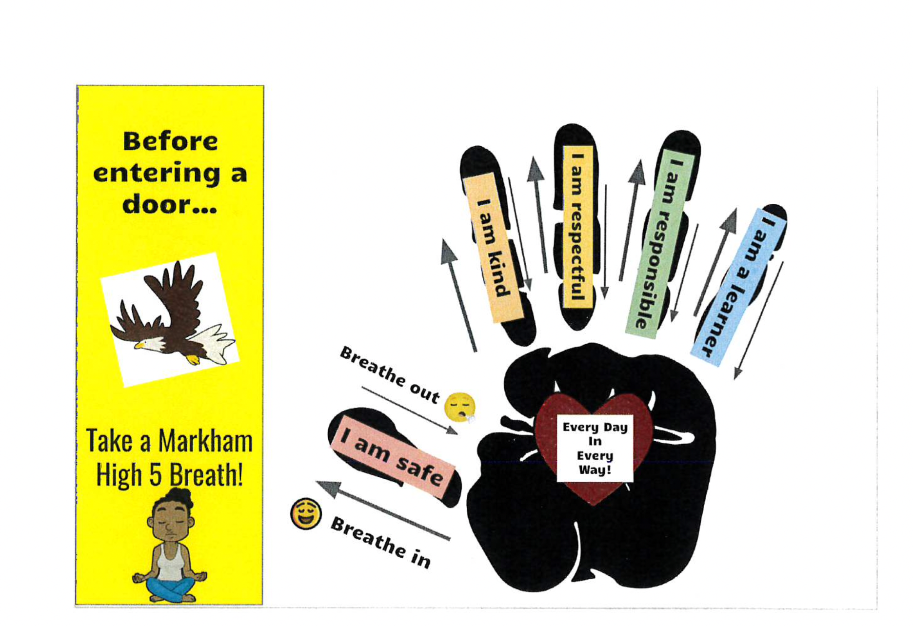

Be well!

Principal T. Brown-Warrens



**Important Dates**

| * **1/11 PTA meeting 6:30 pm-8:00 pm** * **1/16 No School** * **1/20 Sharing with Traniece 9:00 am** * **1/27 Teacher PD no school for students** |
| --- |

**Important Links**

| * **2022-23 School Calendars** - [2022-23 District Calendar](https://www.pps.net/cms/lib/OR01913224/Centricity/Domain/4/PPS-Calendar-2022-23.pdf)| [Español](https://www.pps.net/cms/lib/OR01913224/Centricity/Domain/4/PPS_Calendar-2022-23_Spanish.pdf) | [Tiếng Việt](https://www.pps.net/cms/lib/OR01913224/Centricity/Domain/4/PPS_Calendar_2022-23-Vietnamese.pdf) | [中文](https://www.pps.net/cms/lib/OR01913224/Centricity/Domain/4/PPS_Calendar-2022-23_Chinese.pdf) | [Русский](https://www.pps.net/cms/lib/OR01913224/Centricity/Domain/4/PPS_Calendar-2022-23_Russian.pdf) | [Soomaali](https://www.pps.net/cms/lib/OR01913224/Centricity/Domain/4/PPS_Calendar-2022-23_Somali.pdf) |
| --- |

**PTA Links**

| * **Looking to connect?** Use these links to connect with more grade-level families each month: <https://markhameagles.memberhub.com/>. Updated information is also sent out weekly by the PTA. If you are not receiving PTA emails, please contact a board member at: [MarkhamPTA@gmail.com](mailto:MarkhamPTA@gmail.com). You can also become part of the PTA community on FaceBook by searching for “Markham Elementary PTA” (this is a managed group). * **PTA MemberHub** - To sign up for the Markham PTA, go to: <https://markhameagles.memberhub.com/store?category=Memberships> |
| --- |

**Wellness Corner**

| Want to talk to Ms. Hom or Ms. Knochel? | Have a Private Counseling Need? | Want to talk to Ms. Neve? |
| --- | --- | --- |
| Email:  [mhom@pps.net](mailto:mhom@pps.net)  kknochel@pps.net | Go to: <https://www.westernpsych.com/services/school-based-programs/referral>  Want to know more about Life Stance? Go to: *LifeStance Health, Inc.**(*[*Western Psychological & Counseling Services, P.C*](https://www.westernpsych.com/)*)* | Email: [**eneve@impactnw.org**](mailto:eneve@impactnw.org)  Phone: 971-212-4082  Learn more about SUN: [IMPACTNW.ORG](http://impactnw.org/) |